ADIDAS FIFA WORLDCUP BALL
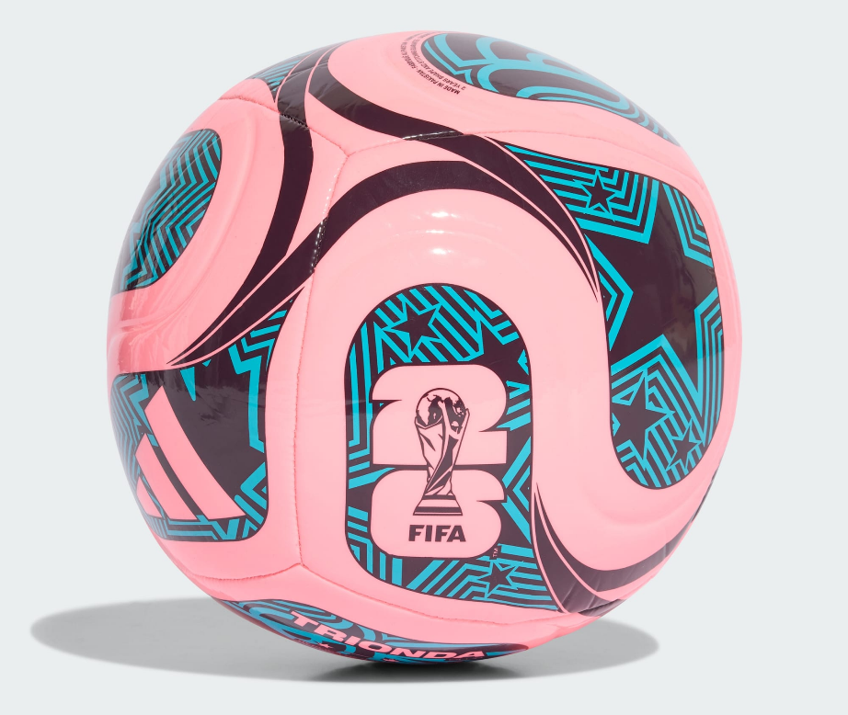
PRICE: Approximately Rs. 14,999

_{Introduction:}
The Adidas FIFA World Cup Ball represents the highest standard of football design, performance, and precision. Created for elite-level play, this ball is engineered to deliver exceptional control, accuracy, and durability on the pitch. Inspired by the world’s biggest football tournament, it reflects Adidas’ commitment to innovation and excellence. Whether used for competitive matches or professional training, the FIFA World Cup Ball offers a premium playing experience trusted by players worldwide.
Product Overview:
The Adidas FIFA World Cup Ball is designed to meet international match standards. Its advanced construction ensures consistent flight and excellent responsiveness. Built for high-performance football, it performs equally well in intense match conditions.
About the Brand:

is a world-renowned sportswear brand known for innovation, quality, and timeless design. With a strong legacy in both sports and streetwear culture, Adidas continues to create footwear that blends performance, style, and durability for global audiences.

Key Features:
- FIFA-approved match ball design
- Seamless surface for accurate flight
- High-quality outer layer for durability
- Excellent touch and control
- Suitable for professional and competitive play
- Lightweight hard shell for impact protection
- Cushioned inner lining for added comfort

Design & Build Quality:
The Adidas FIFA World Cup Ball features a carefully engineered panel design that enhances aerodynamics and stability. Its seamless construction reduces water absorption and ensures consistent performance, even during high-speed play, performs equally well in intense match conditions and structured training sessions.
Storage & Capacity:
The ball maintains its shape when properly inflated and stored. It can be easily carried in standard sports bags and stored without deformation when kept in a dry environment.
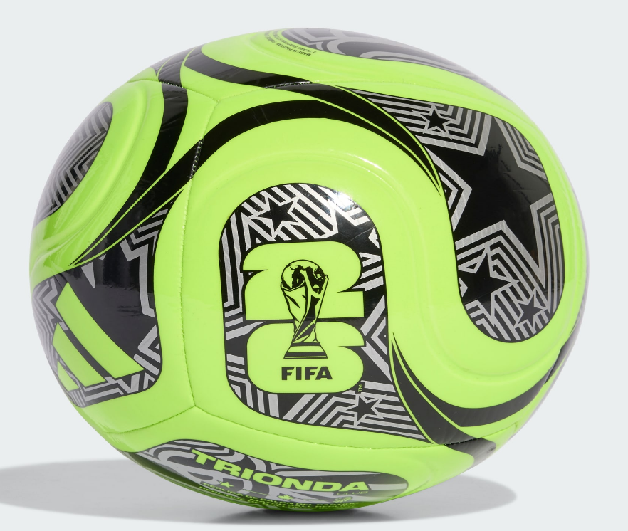

Material & Durability:
Made from premium synthetic materials, the Adidas FIFA World Cup Ball is built to withstand intense match use. The outer surface resists wear and tear, ensuring long-lasting performance across multiple games.
Ideal For:
- Professional football matches
- Competitive tournaments
- Advanced training sessions
- Players seeking elite-level performance
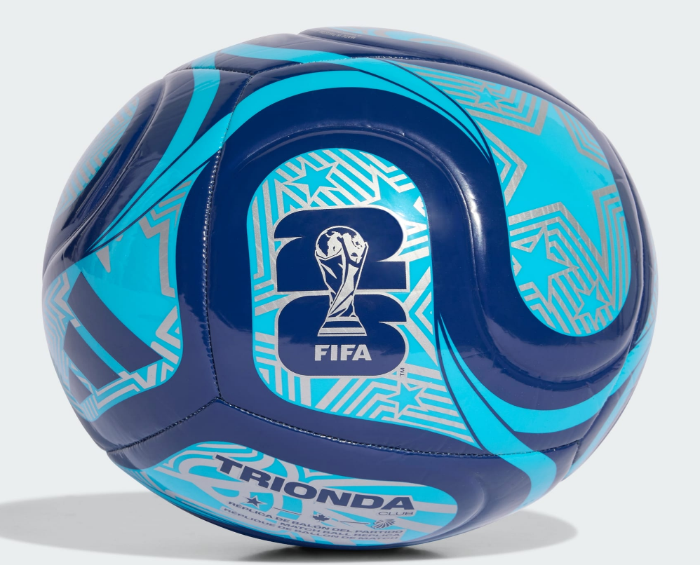

Care Instructions:
- Clean with a damp cloth after use
- Do not machine wash
- Store in a cool, dry place
- Avoid overinflation
Product Specifications:
- Brand: Adidas
- Product Type: Football
- Model: FIFA World Cup Ball
- Size: 5 (Official Match Size)
- Construction: Seamless / Thermally bonded
- Surface: Premium synthetic material
- Approval: FIFA Certified
Product Summary:
The Adidas FIFA World Cup Ball delivers world-class performance, precision, and durability. Designed for the highest level of football, it offers consistent control and flight, making it an excellent choice for serious players and competitive matches, ensuring long-lasting performance across multiple games.

